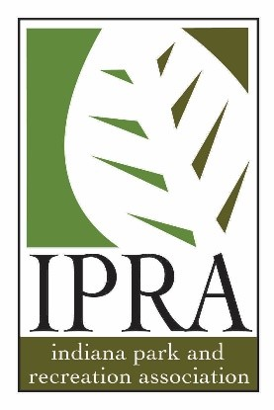

2018 IPRA Conference
Grand Wayne Convention Center
Fort Wayne, IN
January 31 – February 2, 2018

Session Information
TITLE:
SESSION DESCRIPTION (LIMIT OF 100 WORDS):

*Each session can be up to 20 minutes in length. If you plan to have a question & answer session you must incorporate it into the 20 minutes allotted for the session. Up to three PowerPoint slides may be used and feel free to bring props or handouts.

Speaker Information

FIRST NAME:
LAST NAME:
TITLE:
CERTIFICATIONS (IF APPLICABLE):
AGENCY/COMPANY:
COMPLETE MAILING ADDRESS:
CITY:
STATE:
ZIP CODE:
OFFICE PHONE NUMBER:
CELL PHONE NUMBER:
EMAIL ADDRESS:
2018 CONFERENCE AVAILABILITY (SELECT ALL THAT APPLY):
☐ Tuesday
☐ Wednesday
☐ Thursday

SPECIAL NOTES/REQUESTS:

